Student Name

Teacher Name/Class

2021
Mathematics
Year 9 Stage 5.3
Term 4 Task

General Instructions  - Working time − 40 minutes  - Write using black pen.  - Draw diagrams using pencil.  - Calculators approved by NESA may be used.  - Write your name at the top of this page.  - All relevant mathematical reasoning and/or calculations must be shown | Total marks - 48  A – Right-Angled Triangles /12  B – Surds and Indices /18  C – Quadratic Expressions /18  Total /48  Total %

Assessor: Mr Lee

 | Section A – Right-Angled Triangles
1) | Calculate the following, giving your answer correct to 2 decimal places:  a) $$\sin{7.11°}$$  b) $$\cos{7°11'}$$ | 2 marks
2) | For the following triangles, calculate the lengths of the unknown side correct to 2 decimal places  a) 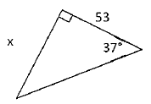  b) 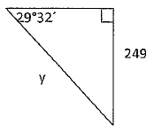 | 4 marks
3) | The pilot (P) of a plane with engine trouble 640m above the ground (G) observes a landing strip (L) 3.6km ahead. Calculate the angle of depression from the pilot to the landing strip? Answer correct to the nearest minute.  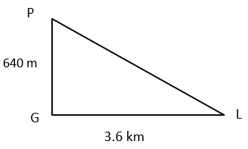 | 2 marks
4) | Three towns A, B and C are located so that A is 25km northwest of B and C is 46km southwest of B.  a) Draw a neat diagram that shows all this information.  b) How far is A from C to the nearest kilometre?  c) What is the true bearing of C from A? | 4 marks
 | Section B – Surds and Indices
5) | Mark each of the numbers in the table below as rational (R) or irrational (I). The first one has been done for you.  $$\frac{7}{9}$$ $$4.6$$ $$-\sqrt{5}$$ $$0.\dot{3}$$ $$2π$$  R | 2 marks
6) | Write $0.4\dot{3}$ as a fraction in its simplest form. | 2 marks
7) | Fully simplify: $$\sqrt{412}$$ | 1 mark
8) | Fully simplify:  a) $$5\sqrt{2}-3\sqrt{2}+9\sqrt{2}$$  b) $$\sqrt{40}+\sqrt{90}-\sqrt{160}$$  c) $$-3\sqrt{5}×2\sqrt{5}$$  d) $$12\sqrt{30}÷18\sqrt{10}$$ | 4 marks
9) | Fully simplify:  a) $$m^{8}×m^{3}$$  b) $${\left(\frac{3x^{2}}{qp^{4}}\right)}^{3}$$  c) $$20m^{15}÷{5m}^{10}×2m^{3}$$ | 3 marks
10) | Fully simplify:  a) $$-(8{y)}^{0}$$  b) $${\left(-6x\right)}^{0}$$  c) $$-{\left(10y\right)}^{0}+10$$ | 3 marks
11) | Simplify, writing your answer with positive indices:  a) $$\frac{20m^{-6}}{{10m}^{-7}}$$  b) $$\frac{{\left(4{x y}^{2}z^{5}\right)}^{-3}}{{\left(x^{-6}y^{-2}\right)}^{3}}$$ | 3 marks
 | Section C – Quadratic Expressions
12) | Expand the following:  a) $$(x-8)(x-6)$$  b) $${\left(6-5y\right)}^{2}$$  c) $$(2k-3m)(2k+3m)$$ | 3 marks
13) | Factorise the following:  a) $$a^{2}-6a-27$$  b) $$8x^{2}+2x-3$$  c) $$16z-{25z}^{3}$$  d) $$a^{3}+{2a}^{2}-{ab}^{2}-{2b}^{2}$$ | 7 marks
14) | Simplify:  $$\frac{a^{2}-1}{a^{2}+2a-3}$$ | 1 mark
15) | Simplify:  $$\frac{1}{x-1}-\frac{2}{x}$$  : | 2 mark
16) | Simplify:  $$\frac{x^{2}-3x}{x^{2}+5x}÷\frac{x^{2}-5x+6}{x^{2}+4x-5}$$ | 3 marks
17) | Solve:  $$\frac{y+3}{5}+2=\frac{y+7}{2}$$ | 2 marks
END OF ASSESSMENT

